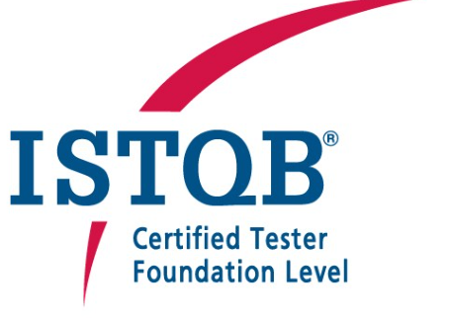
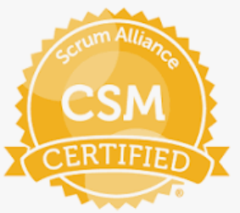

Smit Jain
E-mail: jaismit87@gmail.com
Mobile: + 91- 9663310652

Experience Summary:

- Experienced Automation Quality analyst and Lead with 13+ years of experience in Automation testing, functional testing, Regression Testing, Automation framework Implementation UAT Testing and Defect Management
- Having 4 year on Test Lead/Managing Teams experience, and 2 years as Continuous Quality Expert and Process Manager.
- Worked on preparing Quality Management Plan, Configuration Management Plan. multiple releases.
- Certified Agile Scrum Master and having 8 years of experience in Agile projects.
- Having good experience in setting up Agile teams and coordination between offshore and Onshore
- Provided end to end support for time and business critical project by leading Planning Release, test strategy, plan, execution, documentation, defect management and status reporting.
- Implemented automation testing for web and mobile application using tools like selenium, Appium and QTP
- Experience with Agile, BDD and Gherkin plus strong testing concepts.
- Mobile, iOS and Android test automation experience
- Detailed hands-on experience in working for projects in Life science, Retail and Finance domain, Grid Software domain.
- Also, a skill, result oriented, self-starter and able to work with minimum guidance. team player with strong analytical, design skills, and problem-solving abilities, excellent communications.
- Proven ability to understand business problems and apply technology to formulate workable solutions in high-pressure situations.
- Good planning and organizational skills in coordinating with clients in all aspects of Project from inception through completion. Ability to work in tight schedules and on different applications concurrently.

Work Experience:

- Working as CQE (Continuous Quality Expert), Test Manager in Siemens – Nov 2018 to till date.
- Working as Test Lead for Accenture, Bangalore from April 2010 to October 2018.

Academic Profile:

- B.Tech (Information Technology)– 2009

Skills Summary:

Automation Tools : QTP 11.00, Selenium, Appium, Postman

Testing Management Tools : HPALM 11.52, XRAY

Agile Testing Tools : JIRA with XRAY and Confluence

Testing Frameworks : BDD, Hybrid and Data driven
Scripting Technologies : HTML, VB Script and JavaScript
Domain Expertise : Banking, Consumer Good Services, Freight & Logistics and Finance, Grid Software, IOT
Certification:

ISTQB Foundation Certified
Certified Scrum Master

Professional Experience:

Process Manager, QA Lead / Test Manager – Siemens – Grid Control (GC)
Project : Grid Control – PE Team
Duration : Nov 2022 to till Date
Application Platform: C, C++, Cloud Base Application
Automation – Selenium Cucumber, API Testing
Responsibility:
Working as a Continuous Quality Expert, Process Manager and QA Manager
In current project we are handling the release of Customer specific changes for ~200 Customers Globally, these changes are known as Product Enhancement (PE).
For that given are the role I am performing
- Working as a Kanban Champion as the priority and backlog keep changing day to day basis.
- Defining process and tooling that best suited for the PE Team
- Polarion for Bid Management Team and Jira for Implementation and Delivery Team
- Involve in Polarion and Jira Connector
- Work as QA to make sure every release of Customer the Siemens Security and Safety compliance must follow.
- Focusing on Testing and reporting of Bugs found by the Project and categorized properly.
- Sync between R&D and Delivery Team
- Supporting in Test Automation and Manual Testing to the team

Continuous Quality Expert / Test Expert - Siemens
Project : MindSphere
Duration : 05 Nov 2018 to October 2022
Application Platform: Cloud (AWS/Azure, Private Cloud)- IOT platform
Automation – Selenium Cucumber, API Testing
Responsibility:
As Test Manager is to ensure the managing all the Quality initiative for the MindSphere Project
- Working on Automation Framework and assigning development task to the team.
- Activity and resource planning.
- Cost estimating and developing the budget.
- Controlling time management
- Preparation of Daily Status Reports, Metrics reporting. Analyzing and managing project risk
- Organizing and motivating a team
- Defect Management Process & Reporting Dashboard
- Release Management in Quality Prospective – With different version of Cloud in different time.
- Handle 10 Members of Team with 7 different application and coordinate multiple location in Offshore and Onshore
- Automation Execution, pipeline creation, Selenium cucumber framework

Test Lead, Accenture
Project : Credit Suisse Bank
Duration : 1-Aug-2014 to Oct-2018
Application Platform: Web & Mobile Application Testing
Automation – Mobile Automation Testing using Appium, Perfecto, Web Automation using Selenium
Responsibility:
As a Scrum Master responsibility was to ensure the Product is delivered on time with the Quality
- Responsible for Reviewing the Product Backlog with product Owner
- Working on Agile Methodology
- Managing and Updating JIRA
- Activity and resource planning.
- Responsible for implementing test automation using Cucumber.
- Responsible for Planning, Estimation,
- Review and Approve all Deliverable
- Preparation of Daily Status Reports, Metrics reporting.
- Handling Quality Audits and Information Security Audit.
- Co-ordinating between onshore and offshore teams.
- Working closely with Business team as part of UAT Testing
- Handling Multiple testing project within the line.
- Supporting in Automation framework using Selenium BDD framework

Senior Software Engineer, Accenture
Project : United Parcel Services
Duration : April-2010 to July- 2014
Tools Used : QTP, Selenium, Perfecto, Appium
Application Platform: Mainframe, Mobile & Web Application
Responsibility:
As Senior Software Engineer responsibility was to ensure the Automation of the application timely delivery
- Schedule calls for requirement clarification call with Onshore team.
- Preparing Automation Framework suited for Mobile and Web Automation.
- Preparation of Daily Status Reports, supporting the Team members and supporting them to solve their issues.
- Managing the mainframe Automation using QTP
- Performed Data Driven Test with QTP to test the application for different sets of data.
- Created Reusable actions and functions by using QTP.
- Used Component based approach to develop Automation Scripts, to reduce the cost of maintenance and maximize the re-use of existing test scripts.

Other Roles
Training Coordinator
Duration January 2023 to till date.
- Preparing the Skill matrix for whole grid software team
- Plan the training for the team members based on expertise and project needs.
- Organize the special request of trainings.
- Cost Management of training based on the Annual budget.
- Reporting and Dashboard of training for team and Organization level.

Personal information:
Name: | Smit Jain
Father’s Name: | Prakash Chordia
Date Of Birth: | 27 January 1987
Marital Status: | Married
Nationality: | INDIAN
Languages: | English, Hindi
Hobbies | Travelling, Playing Badminton
Contact Number | 9663310652
Email ID | Jaismit87@gmail.com
Permanent Address | 3053, Prestige Park Square, Banerghatta Road, Nice Road Junction, Bangalore – 560083  Near Sherwood School

I hereby declare that all the facts provided above are true to the best of my knowledge. I shall be solely responsible for any falsification and misinterpretation of any details stated above.
Smit Jain

